10-17-2018
log transformation and FDR 0.05 CpGs
Guannan Shen
ECCHO

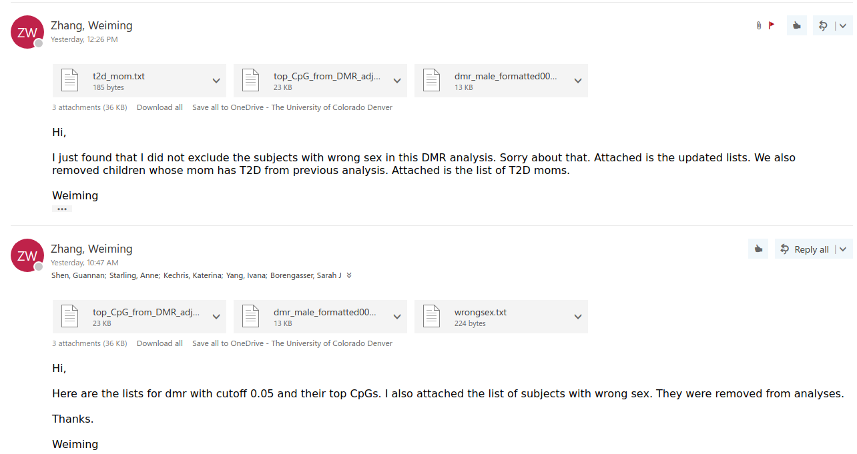
Dataset updated

